**WEEK-3(From Dt 29-05-2023 to Dt 04-06-2023)**

**Detailed Report:** In the third week we went to Eucalyptus & mango fields to know about the problem faced to grow them.

* Eucalyptus is a fast-growing tree native to Australia. As an ingredient in many products, it is used to reduced symptoms of coughs, cold and congestion. It is also features in creams and ointments aimed at relieving muscle and joint pain.
* Eucalyptus was soon used in other traditional medicine systems, including Chinese, Indian Ayurvedic, Greek and European.
* Many medicines are treated for cough and cold but commonly contains eucalyptus. It is also used to reduced the nose and chest to relieve Congestion. Overall, eucalyptus trees offers numerous benefits.
* Similarly, mango trees are large, evergreen trees that are highly prized for their delicious fruits. The mangos are mostly grown and ripened in summer season. Almost half of the world’s mangos are cultivated in India alone, mango trees are striking an impressive with their large size. Even though the mangos are tasty and delicious but it is not easy to grow them.
* To know the problem we decided to go to Eucalyptus and mango fields in Chiruvella Khandrika, and nearby villages we identified the different types of problems, the problems are invasive species, market demand and pricing, harvesting and postharvest management, technical support, water management, climate and weather.

Based on our research the solution to the problems are:

* Implement proper management practices, including site selection, to minimize the risk of invasiveness. Choose non-invasive eucalyptus hybrids are suited for local environment.
* Conducting market research to identified potential buyers and demand for eucalyptus timber, essential oils. Developing strong market and networking strategies to connect potential buyers for long-term relationship.
* Farmers should be trained in proper harvesting methods, considering factors such as fruit maturity, color.
* Carful handling and packing techniques should be followed to minimized for damage. Proper storage conditions, including temperature and humidity control can help prolong fruit shelf life.
* Farmers should seek training programs, workshops provided by agricultural institutions, NGOs. Building partnerships with agricultural experts can help us to access to technical support.
* Farmers should implement proper irrigation methods like drip irrigation methods like drip irrigation conserve to conserve water and improve water-use efficiency.
* Farmers should adopt climate smart agricultural practices including mango variety

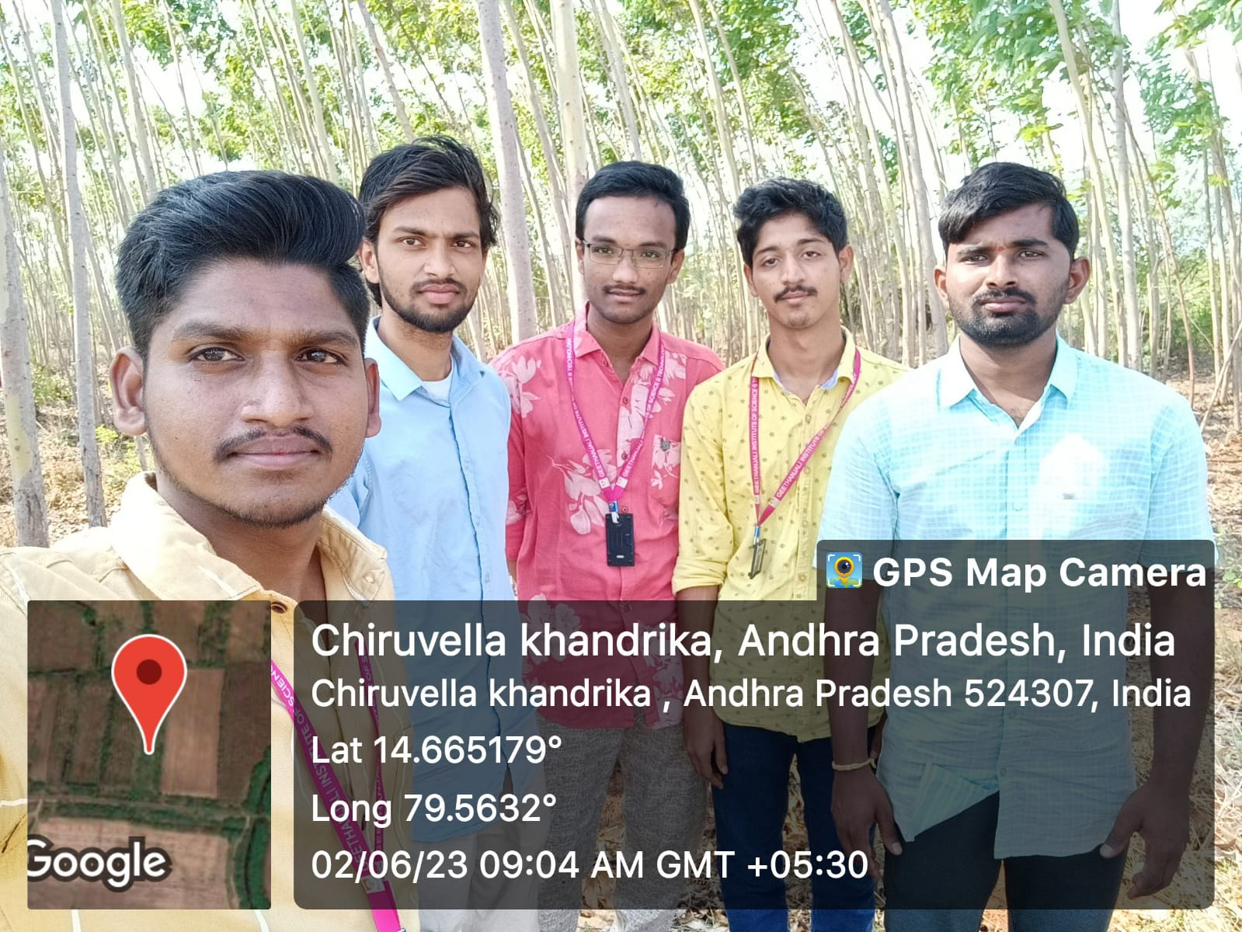

In the above figure we are meet the farmer name prasad in chiruvella khandrika and asked about that farmer on various questions based on that questions we are identified different problems faced by that farmer. Majorly the farmer is faced invasive species, market demand, water requirement, soil management.

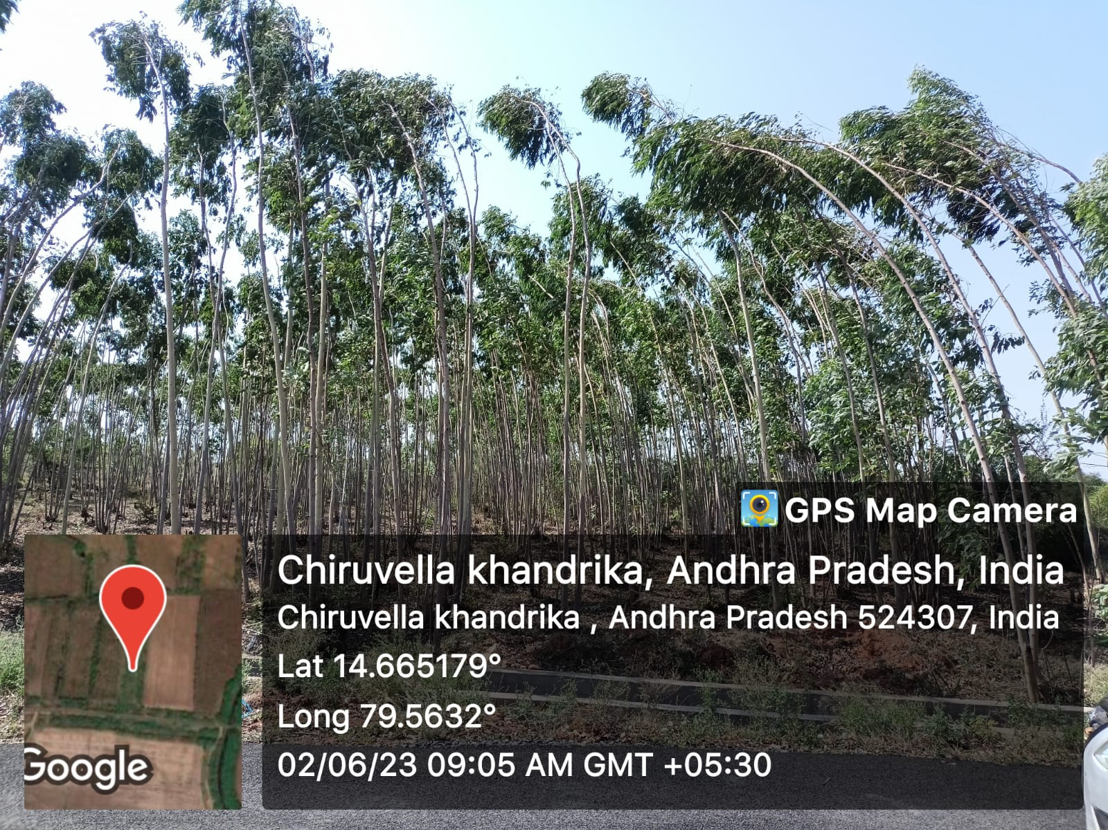

In above figure is show the fields of prasad the farmer had 2 acers of land in that two acers of land he cultivated eucalyptus it takes between 10 to 12 years to mature to become a trees. It cultivated cost as less well. A eucalyptus tree around weight of 400kg approximately. In a hector area of around one and one half trees can be planted.

GUIDE SIGNATURE PROJECT COORDINATOR SIGNATURE HOD SIGNATURE